PRIEDAS 4
Dainų tekstai ir žodžių debesys
Tai yra pratimo „Kokią žinutę tu girdi?” pavyzdys. Galima pasirinkti bet kokios dainos žodžius. Yra keletas internetinių svetainių, kuriose galima rasti dainų tekstus. Žemiau esančiam pavyzdyje, mes pasirinkome iš http://www.azlyrics.com. Puslapio viršuje, dešinėje, paieškos laukelyje reikia įrašyti dainos pavadinimą arba dainininko vardą.
1 pavyzdys
Song “Believer” - Imagine Dragons
First things first
I'ma say all the words inside my head
I'm fired up and tired of the way that things have been, oh ooh
The way that things have been, oh ooh
Second thing
Second, don't you tell me what you think that I can be
I'm the one at the sail, I'm the master of my sea, oh ooh
The master of my sea, oh ooh
I was broken from a young age
Taking my soul into the masses
Write down my poems for the few
That looked at me took to me, shook to me, feeling me
Singing from heart ache from the pain
Take up my message from the veins
Speaking my lesson from the brain
Seeing the beauty through the
(Pain)
You made me a, you made me a believer, believer
(Pain, pain)
You break me down, you build me up, believer, believer
(Pain)
I let the bullets fly, oh let them rain
My luck, my love, my God, they came from
(Pain)
You made me a, you made me a believer, believer
Third things third
Send a prayer to the ones up above
All the hate that you've heard has turned your spirit to a dove, oh ooh
Your spirit up above, oh ooh
I was choking in the crowd
Living my brain up in the cloud
Falling like ashes to the ground
Hoping my feelings, they would drown
But they never did, ever lived, ebbing and flowing
Inhibited, limited
Till it broke up and it rained down
It rained down, like
(Pain)
You made me a, you made me a believer, believer
(Pain, pain)
You break me down, you built me up, believer, believer
(Pain)
I let the bullets fly, oh let them rain
My luck, my love, my God, they came from
(Pain)
You made me a, you made me a believer, believer
Last things last
By the grace of the fire and the flames
You're the face of the future, the blood in my veins, oh ooh
The blood in my veins, oh ooh
But they never did, ever lived, ebbing and flowing
Inhibited, limited
Till it broke up and it rained down
It rained down, like
(Pain)
You made me a, you made me a believer, believer
(Pain, pain)
You break me down, you built me up, believer, believer
(Pain)
I let the bullets fly, oh let them rain
My luck, my love, my God, they came from
(Pain)
You made me a, you made me a believer, believer

http://www.azlyrics.com/lyrics/imaginedragons/believer.html
Nukopijuokite dainos žodžius, po to eikite į www.wordclouds.com.
Įkelkite dainos tekstą.
Šios dainos teksto žodžių debesis atvaizduotas žemiau esančiame paveikslėlyje:
Jei ne visi žodžiai buvo parodyti, norint, kad trūkstami žodžiai būtų rodomi jūsų debesyje, sutraukite žodį „debesis“ arba sumažinkite šių žodžių dažnį žodžių sąraše. Pageidautina sutraukti žodžių debesį, nes svarbu išlaikyti galutinio rezultato žodžių dažnumą.

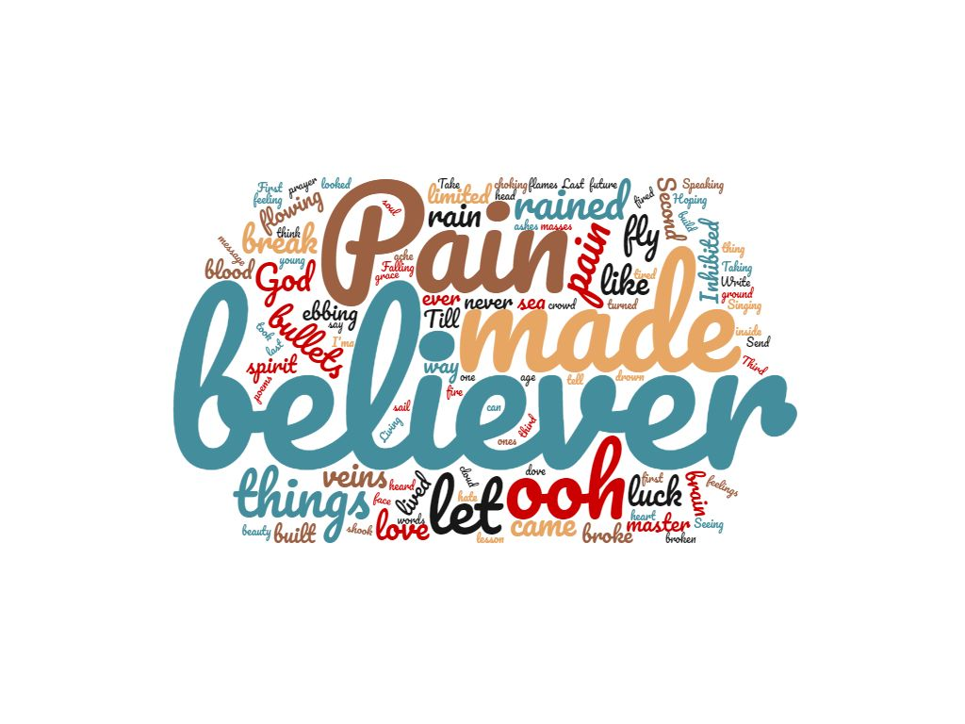
Jūs galite pasirinkti debesies formą, spalvas, šriftą ir, jei norite, šabloną.

2 pavyzdys
Song “Imagine” – John Lennon

Imagine there's no heaven
It's easy if you try
No hell below us
Above us only sky
Imagine all the people
Living for today... Aha-ah...
Imagine there's no countries
It isn't hard to do
Nothing to kill or die for
And no religion, too
Imagine all the people
Living life in peace... You...
You may say I'm a dreamer
But I'm not the only one
I hope someday you'll join us
And the world will be as one
Imagine no possessions
I wonder if you can
No need for greed or hunger
A brotherhood of man
Imagine all the people
Sharing all the world... You...
You may say I'm a dreamer
But I'm not the only one
I hope someday you'll join us
And the world will live as one.

http://www.azlyrics.com/lyrics/johnlennon/imagine.html
Nukopijuokite dainos žodžius, po to eikite www.wordclouds.com.
Įkelkite dainos tekstą.
Šios dainos teksto žodžių debesis atvaizduotas žemiau esančiame paveikslėlyje:
